CBBIA SMALL GRANTS PROGRAM
APPLICATION FORM

Application No._____ (CBBIA use)

The conditions relating to Small Grants are detailed in ‘CBBIA Information about Small Grants’, which should be read before the application is completed. The completed form plus should be emailed to CBBIA Project Administrator, Mr. Napoleon Tiapo, IAIA: Project@iaia.org. Alternatively the form can be completed in hard copy, either typewritten, or handwritten in dark ink, and set out clearly in the spaces provided. The application may not exceed the three sides of the form. Please also supply signed supporting statements from two suitably qualified referees.

1. Title of proposal

Disturbance impacts on breeding seabird populations on Dyer Island and mitigation measures to reduce these impacts

2. Name and address of applicant, and address:

Lauren Waller
Nature Conservator
Western Cape Nature Conservation Board
Walkerbay Nature Reserve
16 17th Avenue Voëlklip
Hermanus
7200

Telephone number: 028-3140062
Fax number: 028-314 1814
Email address: laurencip@hernanus.co.za

3. Brief summary of the proposal
Please explain its purpose and relevance to the CBBIA- objectives, the approaches and methods to be used, expected outputs and results

3a Background
Dyer Island lies in the Atlantic Ocean, 55km west of Cape Agulhas, the southern most point of Africa. From a bird conservation perspective, Dyer Island is one of Africa’s most sensitive Islands.

In the 1970s, this Island supported the world’s largest colony of African Penguins (Spheniscus demersus), about 25 000 pairs. By 2001, the population had plummeted to 2088 pairs, the sixth largest colony (Crawford et al. 1995, Wolfaardt et al. 2001). A range of other seabirds breed on the Island (Barnes 1998), including White-breasted Cormorants (Phalacrocorax lucidus), Cape Cormorants (P. capensis), Bank Cormorants (P. neglectus), Crowned Cormorants (P. coronatus), Kelp Gulls (Larus dominicanus), Hartlaub’s Gulls (L. hartlaubii), Swift Terns (Sterna bergii) and Roseate Terns (S. dougallii). Large roosts of terns, mainly the migratory Common Tern (S. hirundo) and Sandwich Tern (S. sandvicensis), occur in summer. Antarctic Terns (S. vittata), which breed on sub Antarctic Islands, roost here in winter and early spring (Barnes 1998, Whittington 2002). Dyer Island is internationally distinguished as supporting the first-known breeding population of Leach’s Storm Petrels (Oceanodroma leucorhoa) in the southern hemisphere, discovered in 1995 (Whittington & Dyer 1995, 2000; Ryan & Whittington 1997; Whittington et al. 1999a, b, 2001).

The waders of the Island were described by Venter et al. (2002). Based on counts made between September 1999 and November 2001, the three most abundant species were Ruddy Turnstones (Arenaria interpres )(median count 216 birds) and Curlew Sandpipers (Calidris ferruginea) (median 73), both non-breeding migrants from the Palearctic which are present on the Island mainly during summer, and African Black Oystercatchers (Haematopus moquini) (median 58). The oystercatcher is a breeding resident, present on the Island throughout the year. From a conservation perspective, it is Dyer Island’s most valuable species of wader, because its population exceeds the 1% threshold (55 birds) used in the application of criteria of the Ramsar Convention (Wetlands International 2002). The 1% limits for Ruddy Turnstones and Curlew Sandpipers are 1000 and 3300, respectively, substantially larger than the numbers of these species present on the Island. The African Black Oystercatcher is thus a key wader species for detailed monitoring on Dyer Island.

Dyer Island has experienced Avian Cholera outbreaks in the last three consecutive years, with Cape Cormorants experiencing the highest death rate by far (a total of 14000 birds died). The impacts of these outbreaks on the targeted species, as well as other species disturbed by Island management is unknown.

3b Objectives

- Determine if Avian Cholera is occurring at a higher frequency than would naturally occur
- The history of outbreaks on Dyer and other Islands
- Determine if bacteria present is found in higher concentrations on Dyer Island compared with other Islands
- Determine why mainly Cape Cormorants are affected
- Determine the primary carriers of the bacteria
- Set up a monitoring programme to increase knowledge of the impact of the bacteria on the population
- Determine the risk of spread to other populations
- Determine how much movement/interaction there is between birds
- Assess how environmental conditions contribute to outbreaks to determine if the spread is assisted by:
  - Temperature
  - Humidity
  - Food availability
  - Food quality
  - Physiological conditions: moult, egg – laying
  - Psychological conditions: overcrowding, disturbance
- Determine the impacts on subsequent breeding success/population dynamics of impacted species
- Assess the effects of the disturbance created by the outbreak on other species

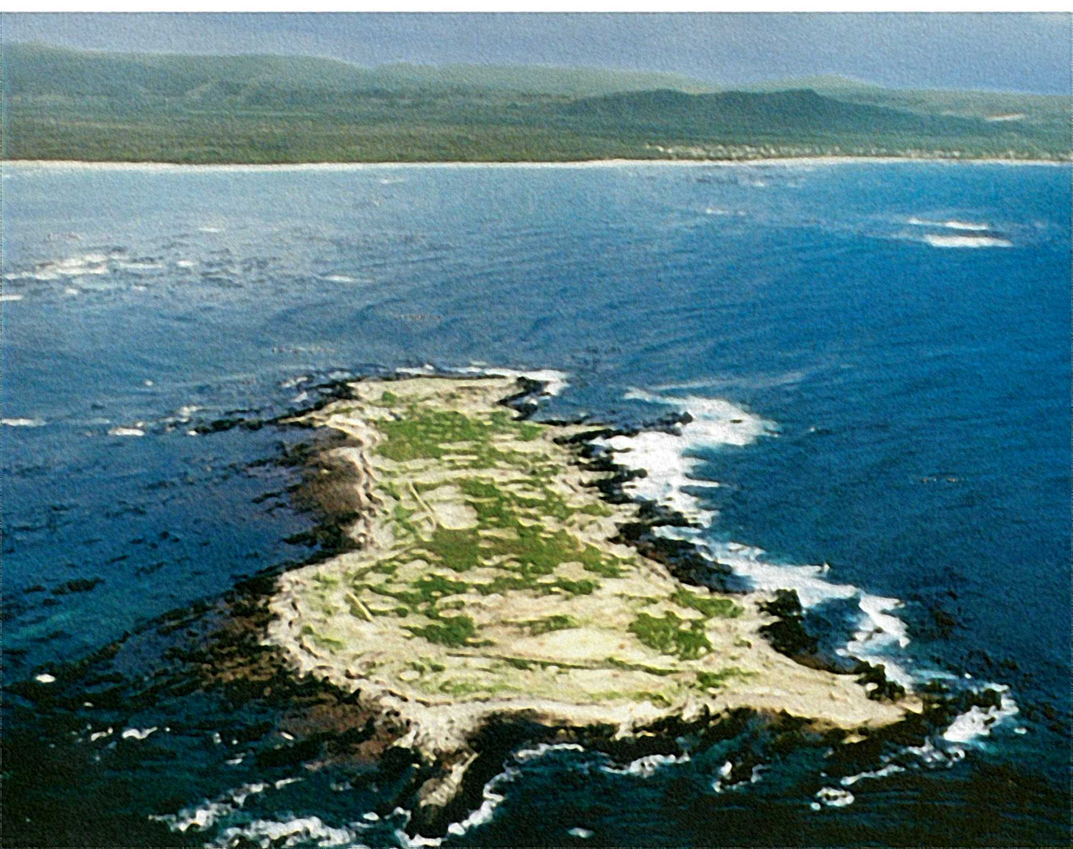

FIGURE 1: Dyer Island Nature Reserve

Summary of proposal, cont. (use this page if necessary)

3c Approaches and methods

The project will run for a 3 years and is part of a PhD project which looks at the disturbance impacts of disease, oil, seals, gulls, tourist and researchers, and mitigation measures to reduce these impacts

The study methods will include collecting of weather data, observation of breading colonies, blood and stomach sampling and the measurement of disturbance by looking at frequency of predation and breading success. Fieldwork will be conducted during monthly visits and data collecting on a daily basis by field staff on the Island. The project will be run under the guidance of Avian Demographic Unit and the Research unit of Marine and Coastal Management.

3d Expected outputs and results (clear deliverables should be identified)

Identification of key indicators to predetermine/predict avian cholera outbreaks.
Using information collected for the formalizing of an avian cholera contingency plan.
Formalisation of a management strategy to control and minimize the spread and impact of the disease.
Lessons learnt at Dyer Island could assist to a better understanding of avian cholera, impacting seabird populations around the world.
The results of this project will be written up in a PhD thesis for the University of Cape Town.

- Details of costing and funding requirements:

- Tools and equipment:
Automatic Weather Station R32 000-00
Personal Computer (Downloading and storage of data) R15 000-00

Amount sought from the CBBIA project: R 47 000 (US $ 7834)*
* assumption $1 = R6

5. Names and addresses of two referees: At least one referee should be from a different place of work to the applicant. Referees must send their statements to IAIA before the closing date. Applicants should give the referees details of the proposal.

Professor Les Underhill: Head of the Avian Demographic Unit , University of Cape Town, Rondebosh
021 650 3227 (tel) 021 650 3434(fax)
lgu@maths.uct.ac.za

Dr Rob Crawford – Marine and Coastal Management
021 402 3140 (tel)
Crawford@deat.gov.za

6. Details of other applications (with addresses where appropriate), together with sums sought or awarded, for this proposal.

N/A

7. Brief curriculum vitae (qualifications, employment) for main proposer:

Miss Lauren Jane Waller (760420 0199 083)

Current Employer: December 2002– current.
Western Cape Nature Conservation Board – Walker Bay Nature Reserve, Nature Conservator

Qualifications:
BSc (Hons)
MSc Conservation Biology

10.Declaration:I certify that the proposal to which this application refers is not supported through any initiatives other than those listed in ‘6’ (above). I confirm that the results of the work undertaken will be the property of the CBBIA. I also confirm my understanding that acceptance of a grant will imply a requirement for the proposed work to comply with the financial, monitoring and evaluation requirements of the CBBIA Program.

Signature: 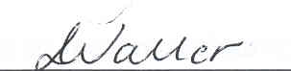 Date: 28 September 2004

FOR CBBIA USE

Received/Acknowledged | SC: Date / Decision | Amount awarded | Report/due

